How to run cucumber file using Jenkins and generate cucumber Json report

Prerequisite:
- User is able to run cucumber runner java file using maven command line.
- Jenkins is installed successfully.

- Add below line in runner file under Plugin cucumber options.
"json:target/cucumber.json"
- Write below command in command line to make Jenkins up and running.
java –jar “path of war file”
Example : java –jar C:\Selenium_Deepak\Jenkins\jenkins.war
- Login to Jenkins using below link.
http://localhost:8080/
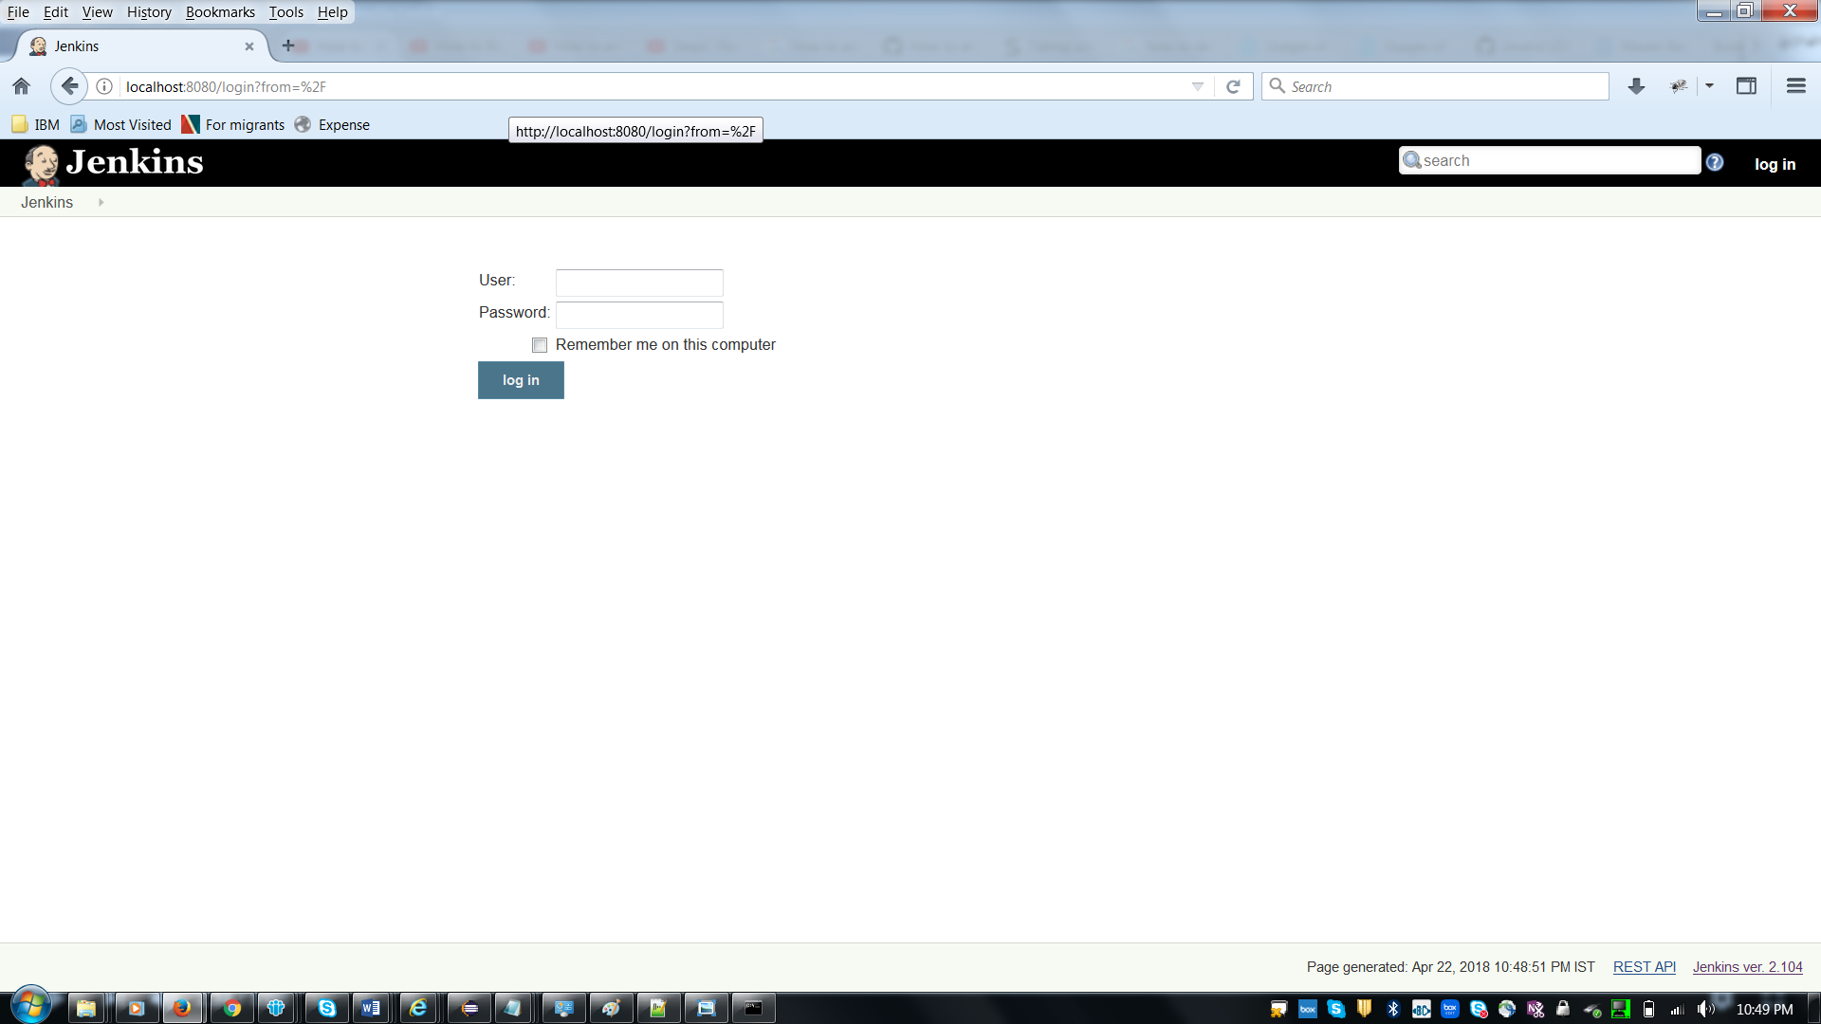

- Click on new Item.
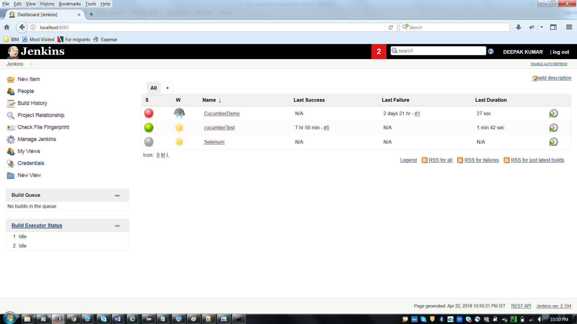

- Enter the item name and select the Maven project then click on OK button.

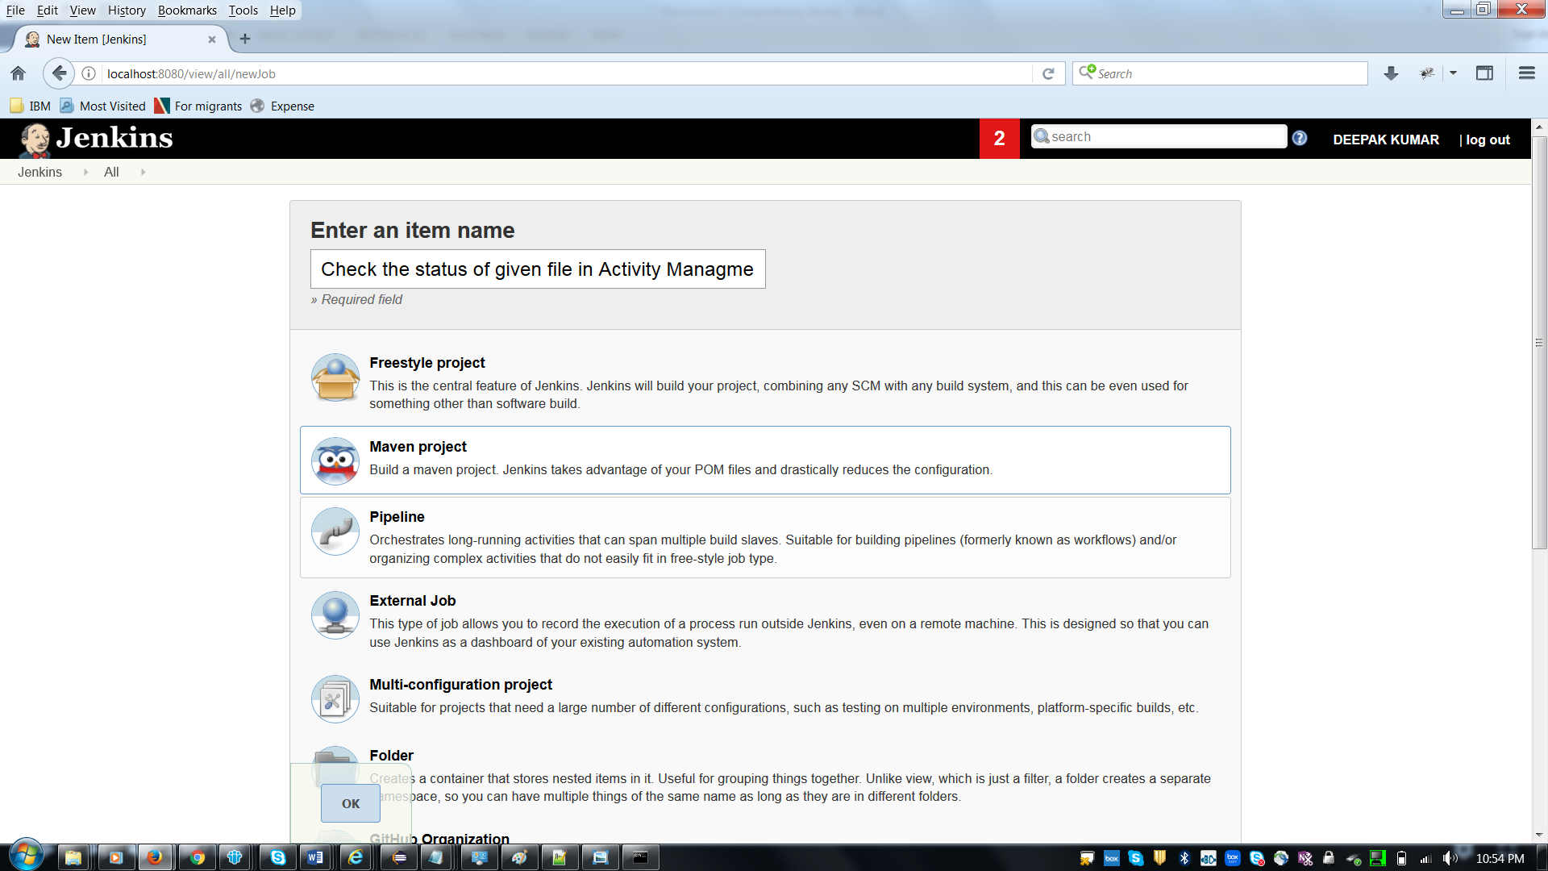
Note: If Maven project option not available under item name selection then first install "Unleash Maven Plugin" from Manage Jenkins → Manage plugin-→ Available tab

- Click on Build tab.
Enter Root POM as “Path of POM File”
Example: C:\WS_SGC\SGC_FlightManagement\pom.xml

Enter Goals and options as clean install

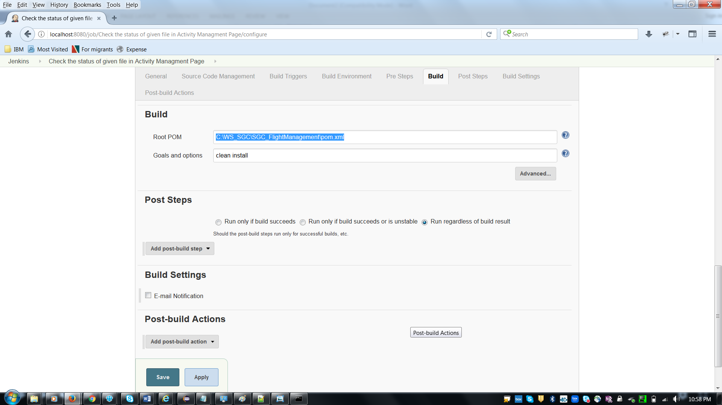

- Click on Post-build Actions
Add post build action as Cucumber Reports
Note: Install the cucumber reports plugin from manage plugins under jenkins if it is not available.
Manage Jenkins → Manage plugin-→ Available tab
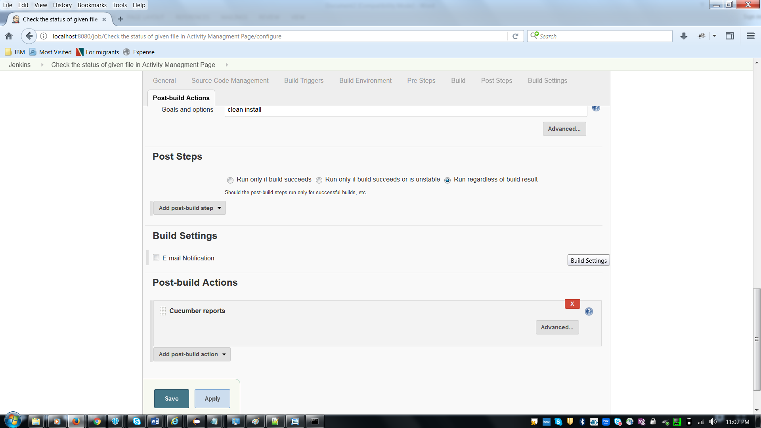

- Click on “Advanced” button under Post build Actions.
Enter Jason report path.
Note: This path can be obtained from runner file under plugin cucumber options.
Example: C:\WS_SGC\SGC_FlightManagement\target
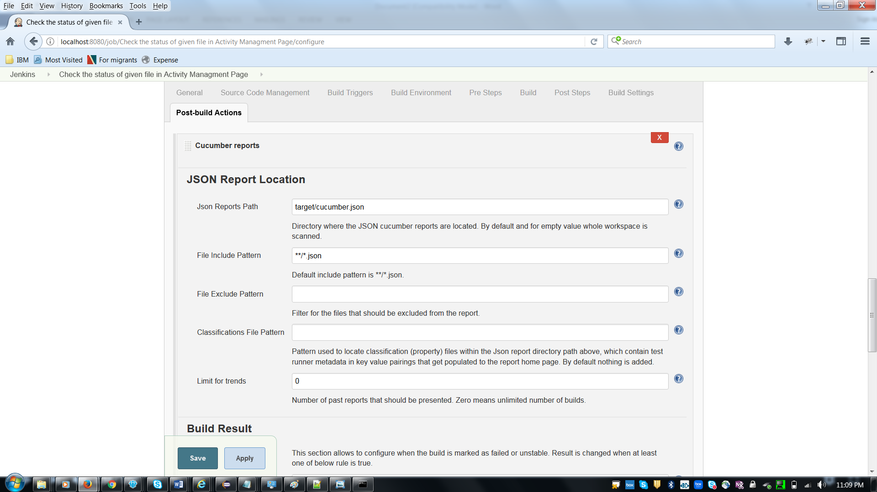
- Click on Apply and then save.
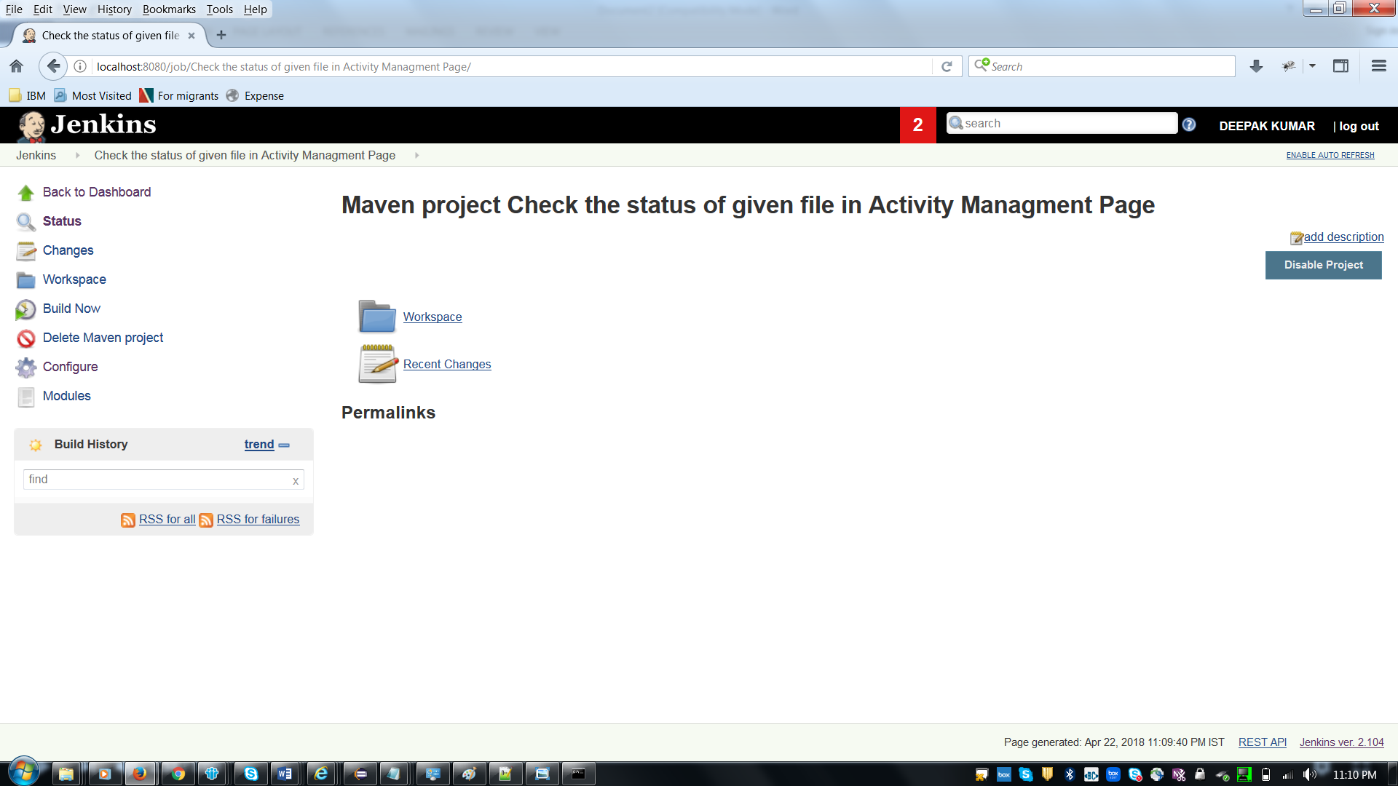
- Now click on “Build Now.”

